

EXP NO 2: CREATE A SIMPLE CLOUD SOFTWARE APPLICATION FOR FLIGHT RESERVATION SYSTEM USING ANY CLOUD SERVICE PROVIDER TO DEMONSTRATE SAAS.
DATE:
AIM:
To create a simple cloud software application for flight reservation system using any cloud service provider to demonstrate saas.
PROCEDURE:
step1: Go to zoho.com.
step 2: Log into the zoho.com.
step 3: Select one application step.
step4: Enter application name as flight reservation system.
step 5: Created new application flight reservation system.
step 6: Select one form
step 7: The software has been created.

step1: Go to zoho.com.
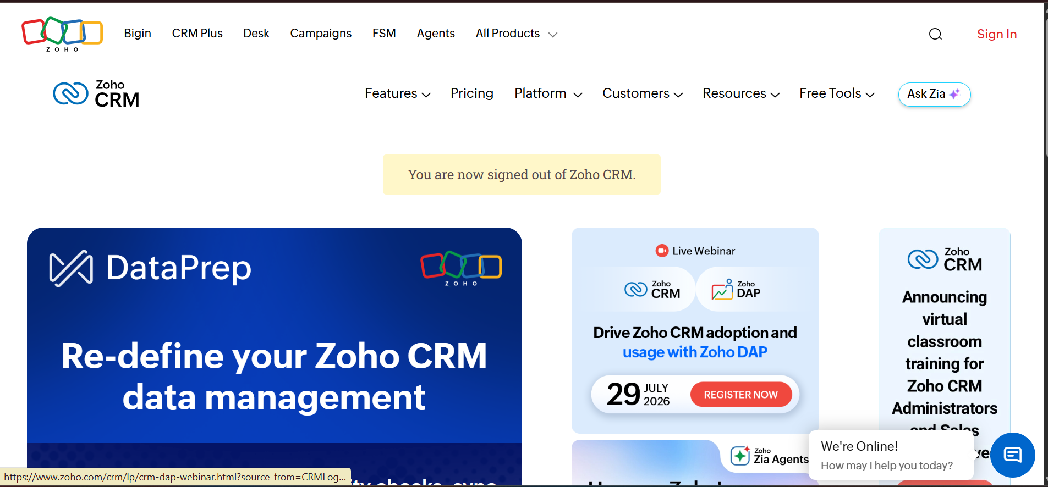

step 2: Log into the zoho.com.
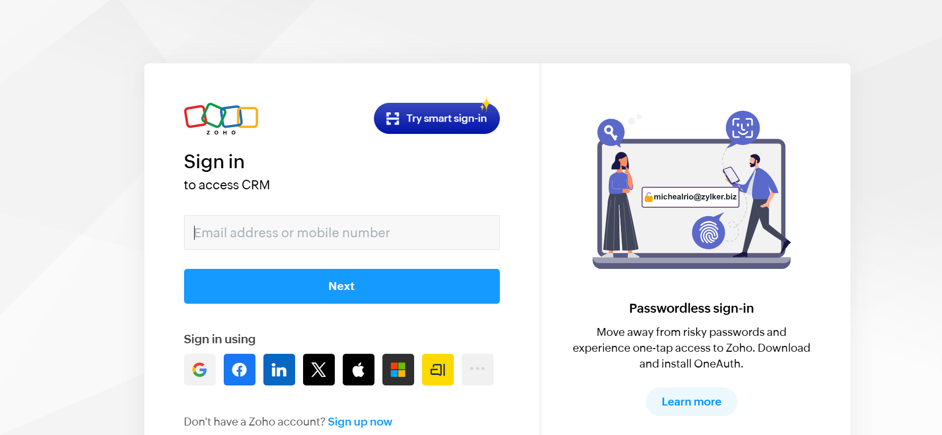
step 3: Select one application step.
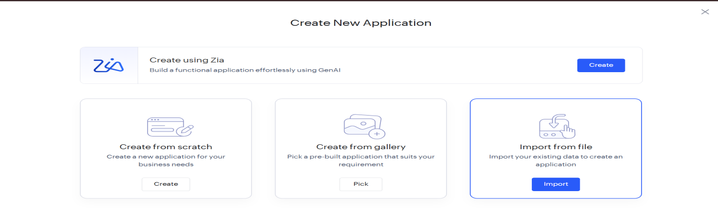
step4: Enter application name as flight reservation system.
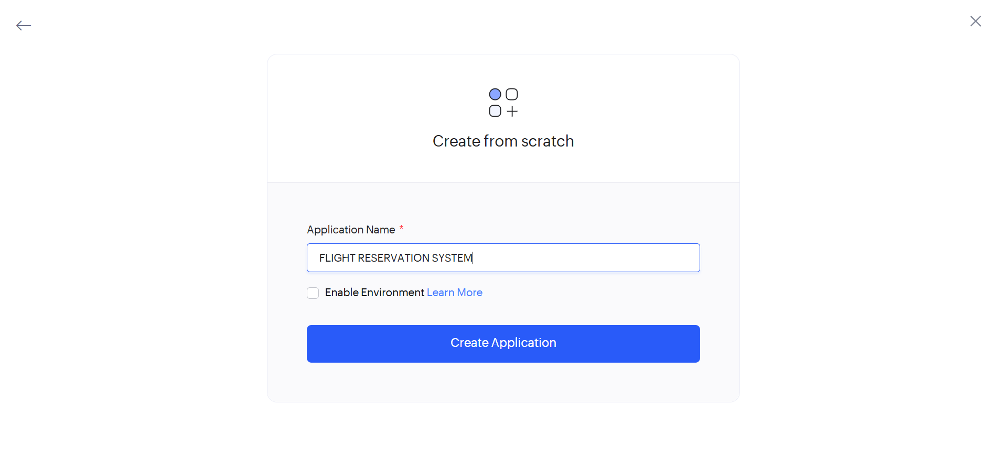
step 5: Created new application flight reservation system. 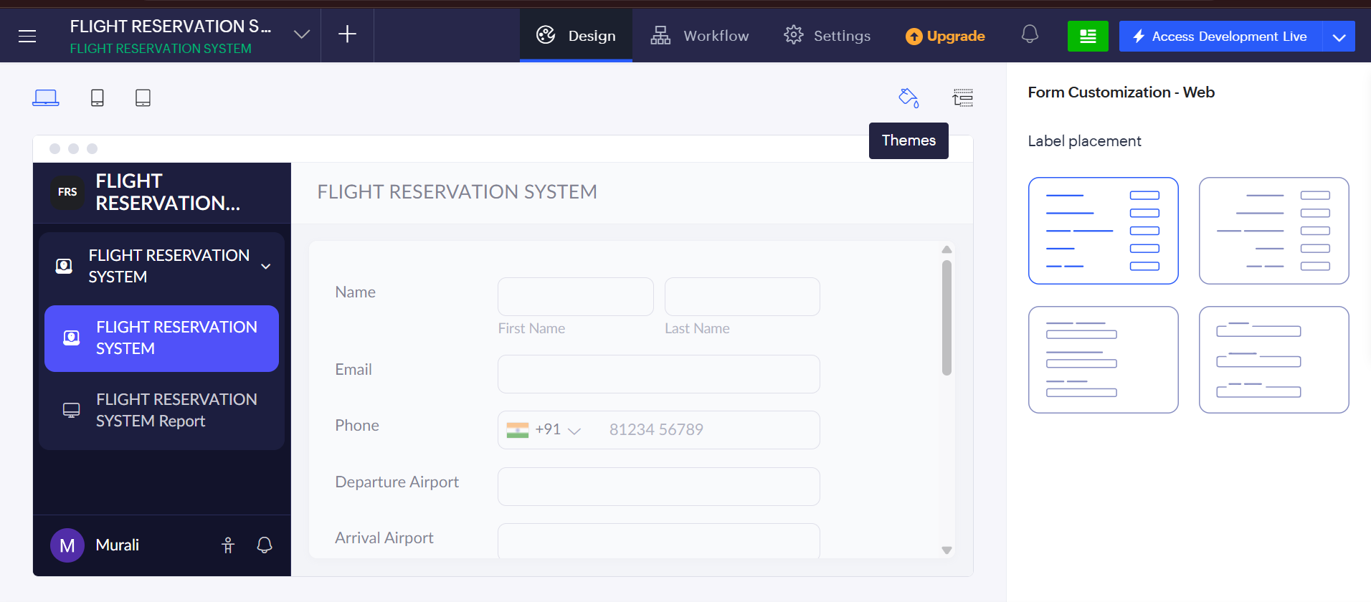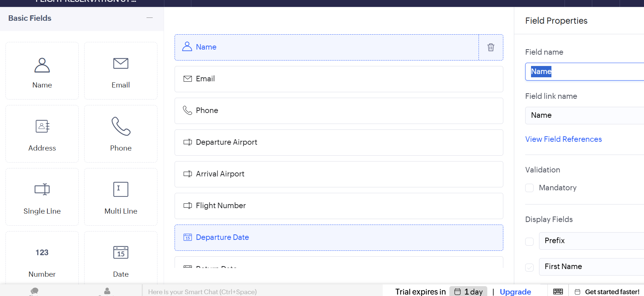
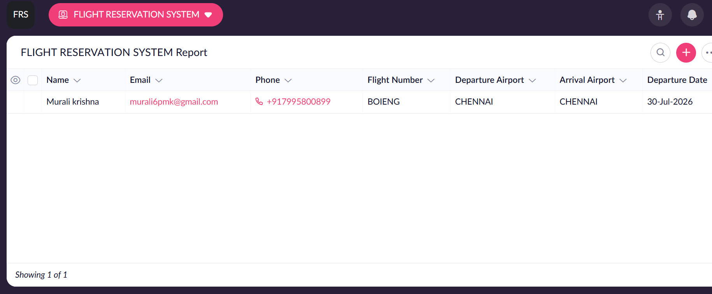

step 6: Select one form
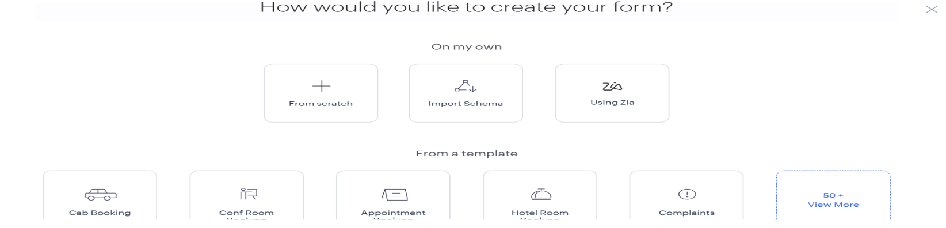

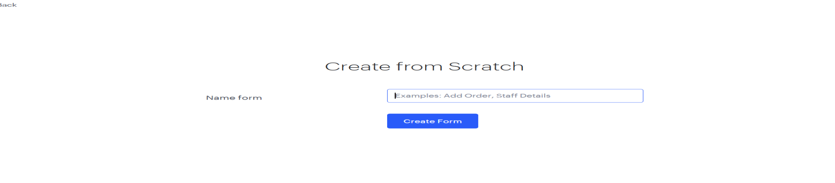

step 7: The software has been created.
